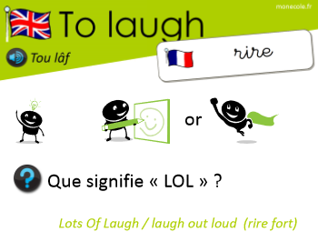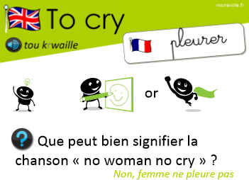
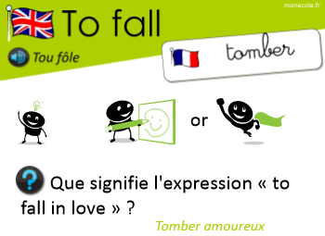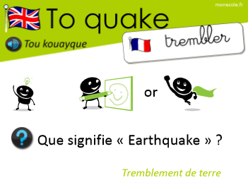
Simon says …

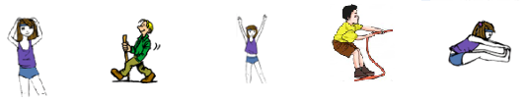
Touch your Walk ! Put up Pull ! Touch your
head ! your arms ! toes !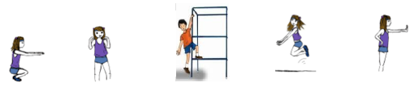
Bend your Touch your Climb ! Jump ! Stop !
knees ! shoulders !

