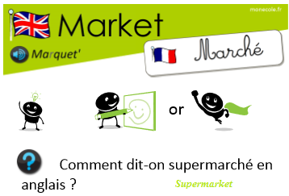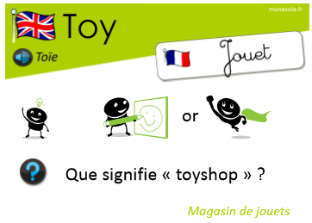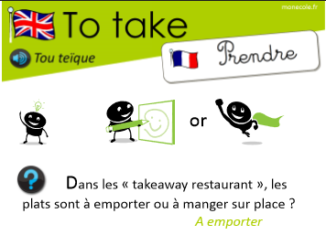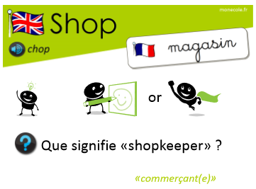
La devise du Royaume-Uni est la livre sterling (£ / GBP). Il y a 100 pence (p) dans une livre (£).

British money
Coins :
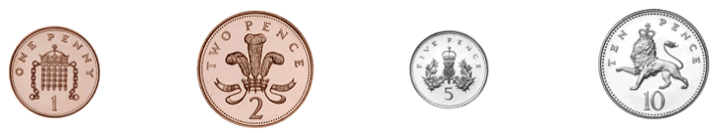
one penny two pence five pence ten pence

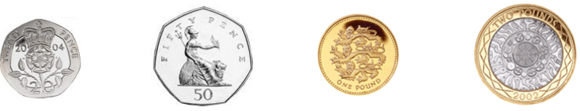
twenty pence fifty pence one pounds two pounds

Bank notes :
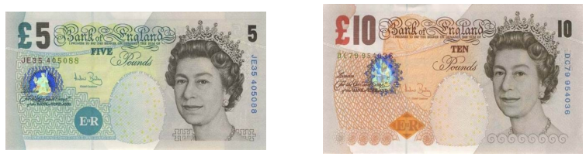
five pounds ten pounds

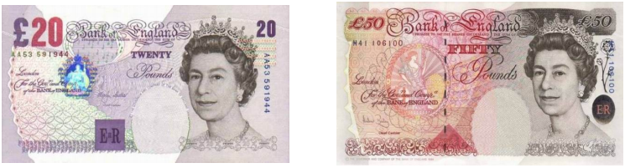
twenty pounds fifty pounds

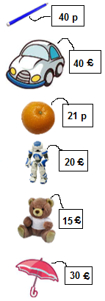
How much is the pencil ?
It's forty pence.

How much is the car ?
It's forty pounds.

How much is the orange?
It's twenty-one pence.

How much is the robot?
It's twenty pounds.

How much is the teddy bear?
It's fifteen pounds.

How much is the umbrella ?
It's thirty pounds.

