Exercise Book
Second Year

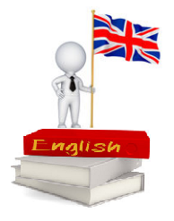

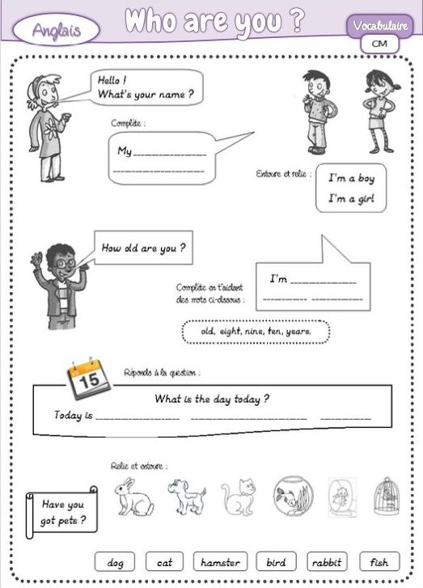

U1 (année 2)- My Family
Connaître la famille royale d’Angleterre.

Lesson 1

Exercise 1 : Who is it ? Relie d’une même couleur la caricature, le portrait et le prénom de chaque personne.

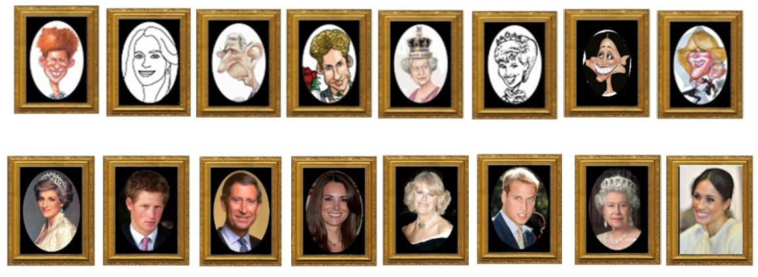

Elizabeth II Charles Diana Harry Meghan William Camilla Kate

Exercise 2 : Royal family. L’arbre généalogique de la famille royale. Aide-toi du texte pour reconstituer l’arbre généalogique de la famille royale d’Angleterre :
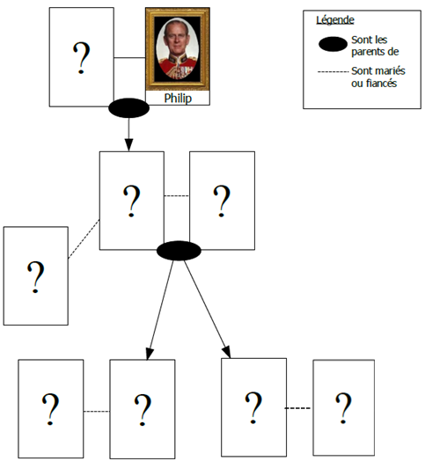
La maison des Windsor :
1
- La reine Elizabeth est l’épouse du Duc Philip.
1
- Ils ont eu 4 enfants : Charles (1948), Anne (1950), Andrew (1960) et Edward
(1964).
2
7
6
3
- Charles a épousé Diana en 1981.
8
7
6
5
4
3
2
- Ils ont eu deux enfants : William (1982) et Harry (1984).
4
- Charles et Diana ont divorcé en 1996.
- Diana est morte en 1997 à Paris dans un accident de voiture.
- Charles a épousé Camilla en 2005.
5
- William et Kate se sont mariés le 29 avril 2011.
- Harry et Meghan se sont mariés le 19 mai 2018.

Redonne à chaque portrait son numéro.
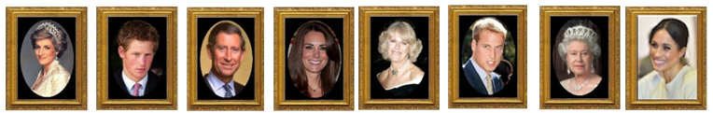

Exercise 3 : Connects the word drawing : My family
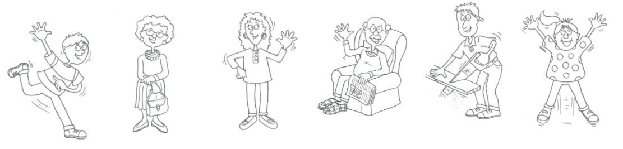
Father
Mother Brother
Grandfather Sister Grandmother

U1 (année 2)- My Family
Connaître le vocabulaire de la famille.

Lesson 2

Exercise 1 : Write the family word : Father, Mother, Brother, Grandfather, Sister, Grandmother
I'm Lisa. It's my family.

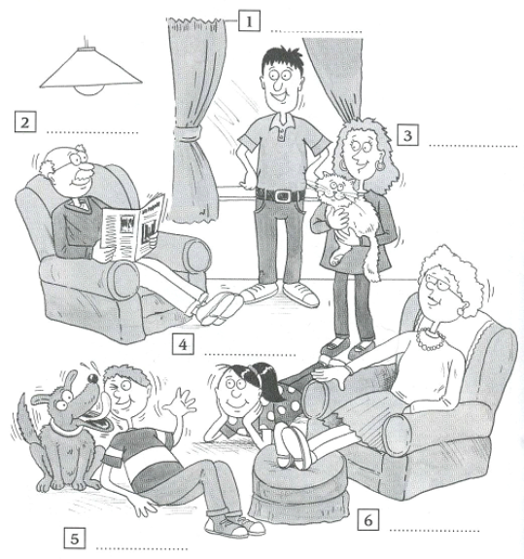

Complete the text :
My name is …................,
my mother is ….................
my father is…....................
Fireman
I have …... brother and
Teacher
...… sister.
I have a .................... and a
..........................”

Exercise 2 : Read the text :

Hello, I’m Bob. This is my family. My father is Greg, my brother is Thomas, my sister is Meg, my mother is Daisy, my grandmother is Sarah and my grandfather is Peter.

Now, match the right name at the right place.

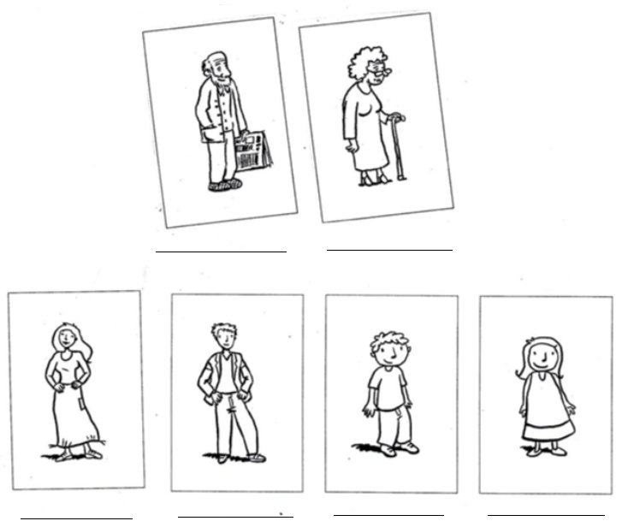

U1 (année 2)- My Family
Connaître le vocabulaire des métiers.

Lesson 3

Exercise 1 : Draw the family.

1/ This is my family.
2/ I am Lili.
3/ My mother is Maria.
4/ My father is John.
5/ I have got two brothers, Jim and Harry.
6/ Have you got any cousins ?
7/ Yes, I have got two cousins.
8/ How old are you ?
9/ I am ten years old.

Exercise 2 : Write the job : fireman, teacher, florist, policeman, doctor,
nurse, cook, hairdresser
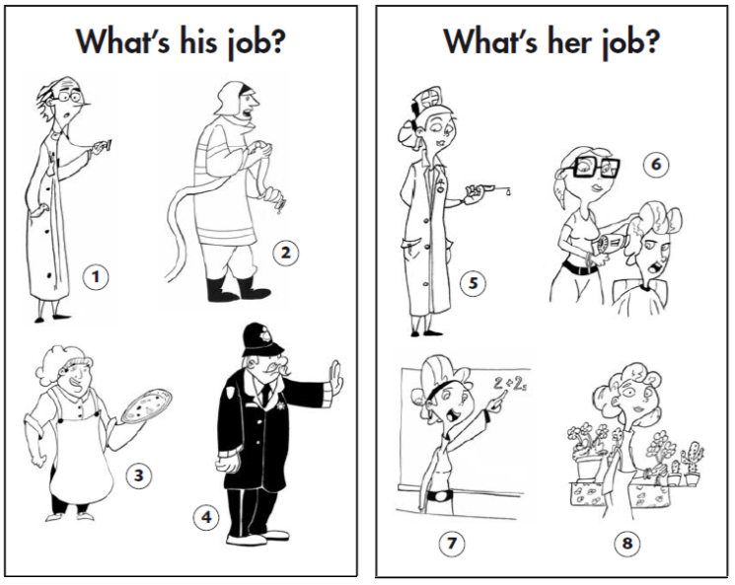
1/...........................

2/...........................

3/...........................

4/...........................

5/...........................

6/...........................

7/...........................

8/...........................

Exercise 3 : Write in the holes.
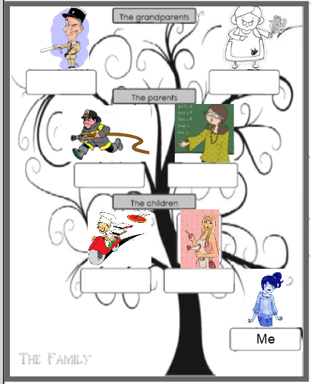
My family

My grandfather is..........................

My ....................is ........................

My ....................is ........................

My ....................is ........................

.......................................................

........................................................

U1 (année 2)- My Family
Connaître le vocabulaire de la famille.

Lesson 4

Exercise 1 : Write the tongue twister.

.............................................................................................................................

Exercise 2 : Colour the family.

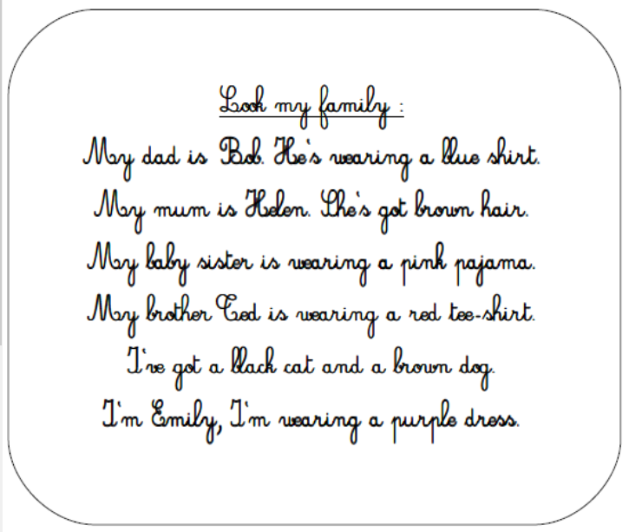
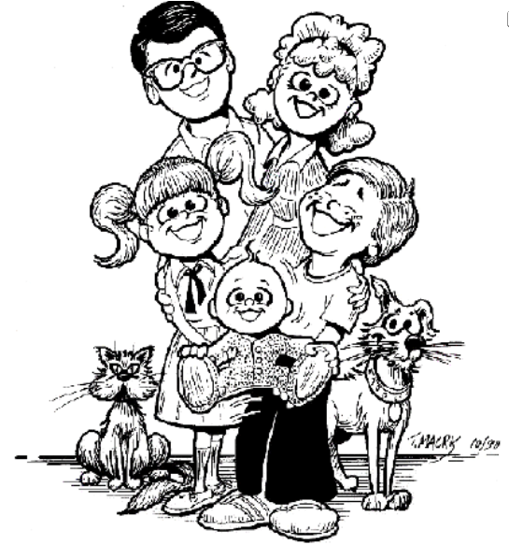

Exercise 3 : Draw and present your family.

.............................................................................................................................

.............................................................................................................................

.............................................................................................................................

.............................................................................................................................

.............................................................................................................................

.............................................................................................................................

.............................................................................................................................

.............................................................................................................................

U1 (année 2)- My Family
Savoir se présenter.
Lesson 5

Exercise 1 : Présente-toi en écrivant un dialogue en t’aidant de celui de Ben et ses amis.

.............................................................................................................................

.............................................................................................................................

.............................................................................................................................

.............................................................................................................................

.............................................................................................................................

.............................................................................................................................

.............................................................................................................................

.............................................................................................................................

.............................................................................................................................

.............................................................................................................................

.............................................................................................................................

.............................................................................................................................

.............................................................................................................................

.............................................................................................................................

U2 (année 2)- What time is it ?
Connaître la carte du Canada.
Lesson 1

Exercise 1 : Write the name of the following towns in the right place :
Halifax, Montreal, Ottawa, Regina, Calgary, Vancouver.

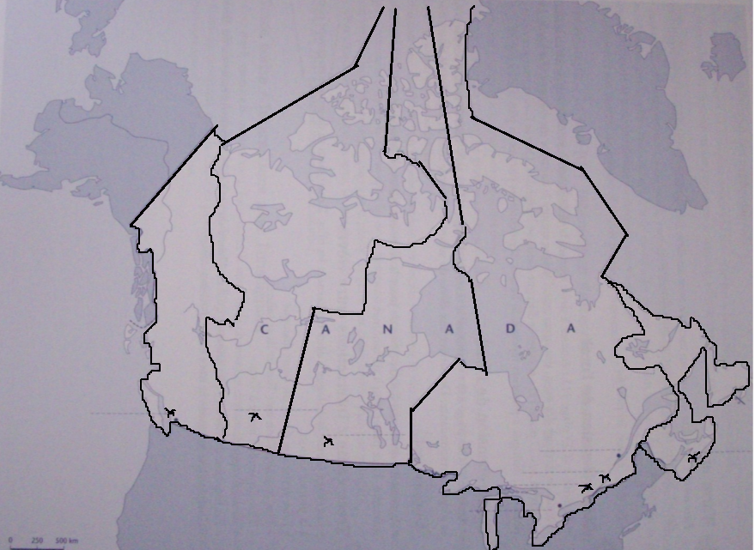

Colour the time zones.

Exercise 2 : Write in the holes.

..................................is a very big……………….. When it’s ………….

o’clock on the ………. coat, it’s ................... o’clock on the ……… coat.

U2 (année 2)- What time is it ?
Savoir donner l’heure et les salutations.
Lesson 2

Exercise 1 : What time is it ?

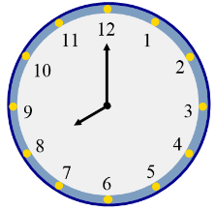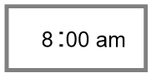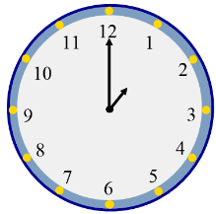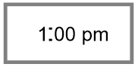

Good .............................. ! Good .................................. !

It's ...........................o'clock AM, It's ...................... o'clock PM,

time for ................................... time for ...........................

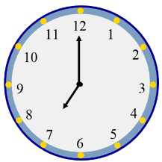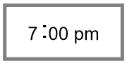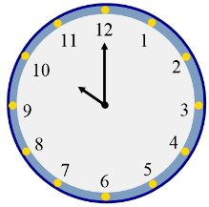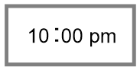

Good .............................. ! Good .................................. !

It's ...........................o'clock PM, It's ...................... o'clock PM,

time for ................................... time for ...........................

U2 (année 2)- What time is it ?
Connaître l’écriture des nombres de 1 à 12.

Lesson 3

Exercise 1 : Write the numbers.
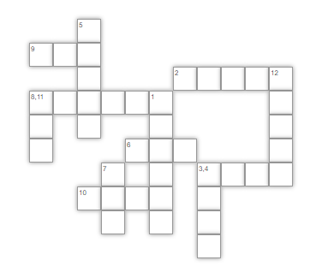

Exercise 3 : Look and write the numbers.

..........................................................................................................................

..........................................................................................................................

..........................................................................................................................

Exercise 2 : Listen the song and put in order.
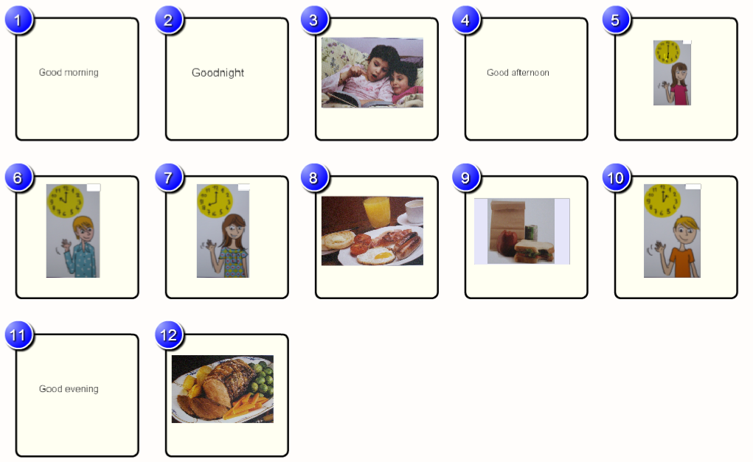

.............................................................................................................................

Exercise 4 : Write the tongue twister.

.............................................................................................................................

U2 (année 2)- What time is it ?
Connaître le vocabulaire autour de l’heure.

Lesson 4

Exercise 1 : Complete the song with : dinner, good morning, lunch, good night, good afternoon, breakfast, good evening.

What time is it ?

What time is it ?
Look at the clock !
Can you tell it ?
It's eight o'clock.
............................, ........................., .......................
It's time for ........................... !

What time is it ?
Look at the clock !
Can you tell it ?
It's one o'clock.
............................, ........................., .......................
It's time for ........................... !

But not in France, not in France, not in France !

What time is it ?
Look at the clock !
Can you tell it ?
It's six o'clock.
............................, ........................., .......................
It's time for ........................... !

But not in France, not in France, not in France !

It's ten o'clock
... ............................., ..............................
It's time to sleep !
... ............................., ..............................

But not in France, not in France, not in France !
...Not in France !
N'oublie pas de faire une illustration de chaque paragraphe.

Exercise 2 : Write the right sentences.

.............................................................................................................................

.............................................................................................................................

.............................................................................................................................

U3 (année 2)- What do you like ?
Connaître les verbes d’action.
Connaître les sports d’hiver.

Lesson 1

Exercise 1 : Write the sports.
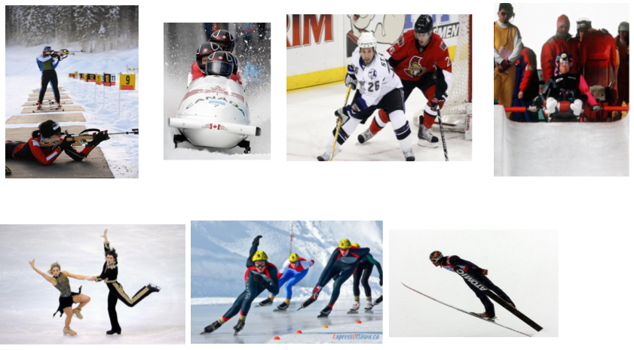

Exercise 2 : Write in the holes.

Ice hockey, ……………………, ice skating, ……………………., Alpine

and Nordic skiing are ………………….. winter …………………… sports.
U3 (année 2)- What do you like ?
Lesson 2

Exercise 1 : Connects the word drawing.
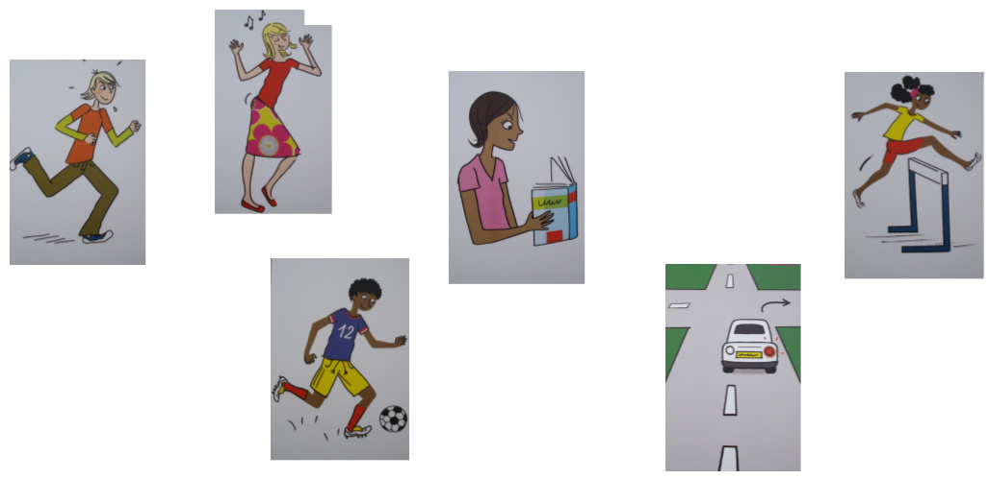
to dance to turn to play football
to run to jump to read

U3 (année 2)- What do you like ?
Connaître les verbes d’action.
Lesson 3

Exercise 1 : Write the word under the picture.
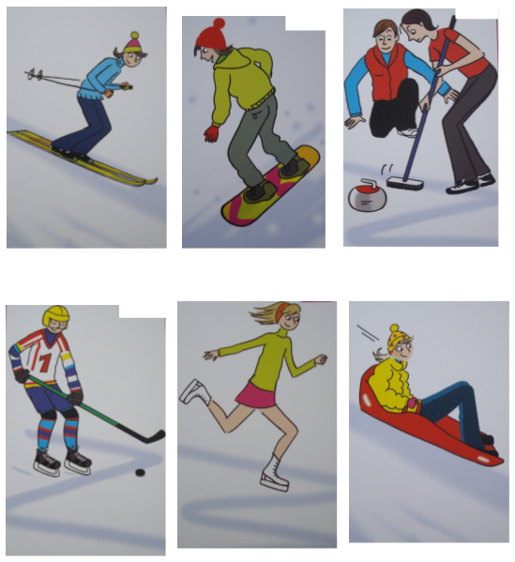

Exercise 2 : Write the actions.
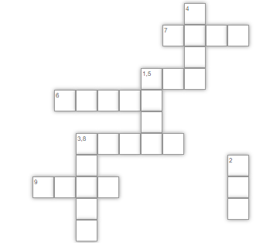
Exercise 3 : Write the sentences.

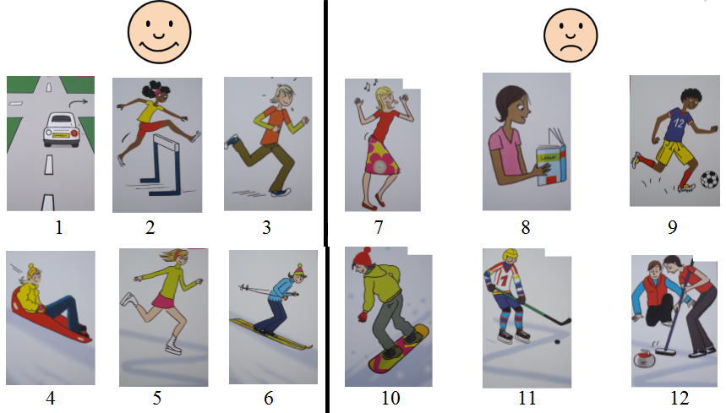

............................................................................................................................

............................................................................................................................

............................................................................................................................

............................................................................................................................

............................................................................................................................

............................................................................................................................

............................................................................................................................

............................................................................................................................

............................................................................................................................

............................................................................................................................

............................................................................................................................

............................................................................................................................
Exercise 4 : Write the tongue twister.

.............................................................................................................................

U3 (année 2)- What do you like ?
Savoir dire ce que l’on aime.
Lesson 4

Exercise 1 : Write the sentences.

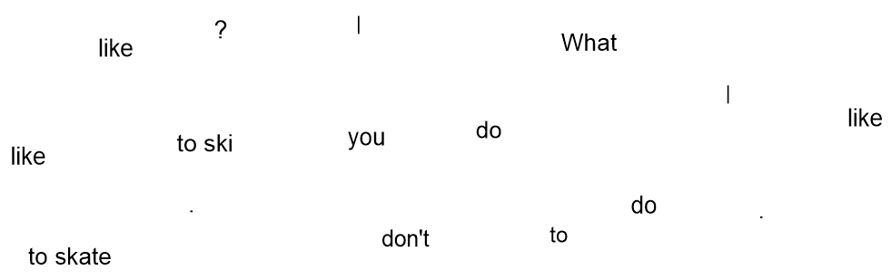

............................................................................................................................

............................................................................................................................

............................................................................................................................

Exercise 2 : Utiliser les mots de liaison : and (et), but (mais), or (ou).
What do you like to do ?
I like to ski ................... I don't like to slide ................ to skate.

What can you do ?
I can play football ......................... I can't swim.

What do you like ?
I like the snowboard ........................ the sledge.

U4 (année 2)- Are you hungry ?
Connaître le vocabulaire de Noël.

Lesson 1

Exercise 1 : Christmas lunch.
Observe ce repas de Noël et relie les mots à leur représentation.
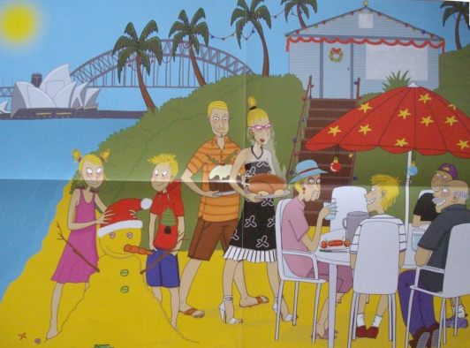

Christmas tree

Turkey

Cracker

Decorations

Garland

Holly

Christmas pudding

Exercise 2 : Write in the holes.

In …………………., ……………………… is in .......................... It's very

hot and ............................................ have ..........................................................

in the …………………. or on the ………………………...

Exercise 3 : Connects the word drawing.
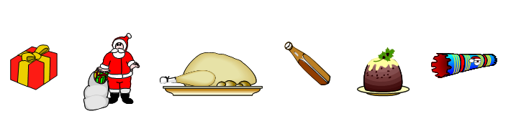
cracker turkey
present gravy
Christmas pudding
Father Christmas

U4 (année 2)- Are you hungry ?
Connaître les aliments.
Lesson 2

Exercise 1 : Write the word under the picture.
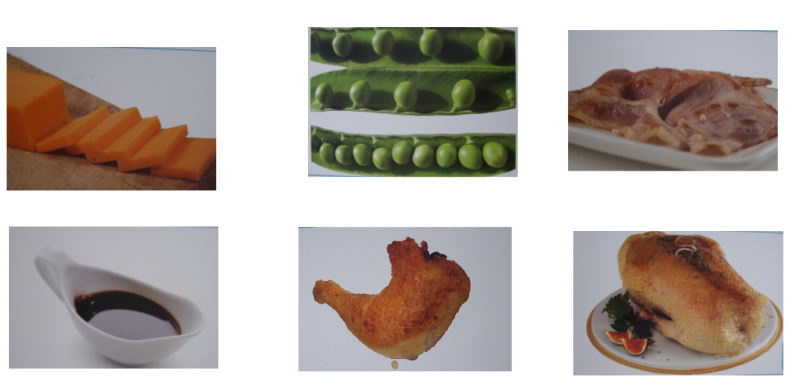

U4 (année 2)- Are you hungry ?
Connaître les aliments.
Lesson 3

Exercise 1 : Write the word under the picture.
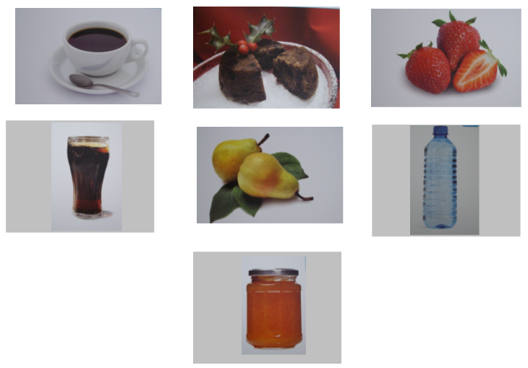

Exercise 2 : Retrouve les différents aliments. Entoure les lettres de différentes couleurs.

................................................ ...................................................

................................................ ...................................................

................................................ ...................................................

................................................

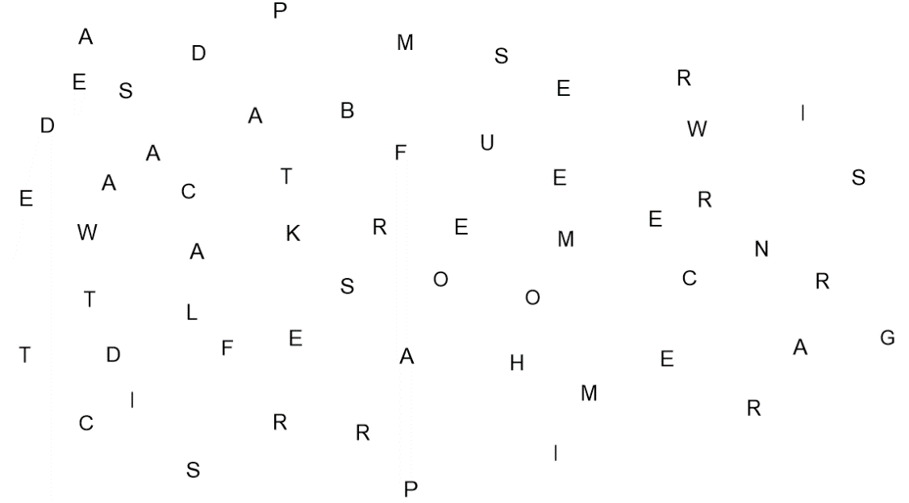
Exercise 3 : Thirsty or hungry ?
Entoure en bleu les aliments et en vert les boissons
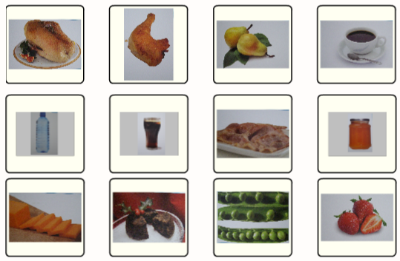

Exercise 4 : Write the sentences.
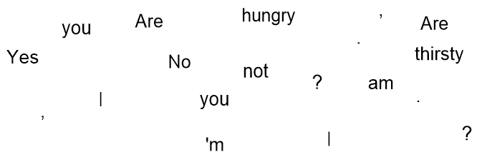
........................................................................................................................

.........................................................................................................................

Exercise 5 : Listen the song and put in order.
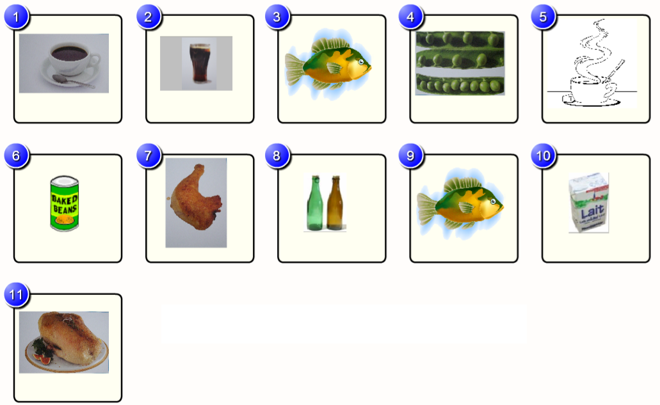

.............................................................................................................................

U4 (année 2)- Are you hungry ?
Connaître les questions courtes.

Lesson 4

Exercise 1 : Separate the words. Then write the sentences.

Areyouhungry?Yes,Iam.IliketoeatChristmaspudding.

.............................................................................................................................

Exercise 2 : Write the word.

yteukr ....................................................

yragy ....................................................

epsar......................................................

delaamarm..................................................

ofceef....................................................

Exercise 3 : Write the tongue twister.

.............................................................................................................................

Exercise 4 : Write the answer.

Are you French ? ..............................................................

Are you thirsty ?...............................................................

Are you happy ?...............................................................

Are you Australian ?........................................................

Are you hungry ?.............................................................

Can you play tennis ?......................................................

Do you like oranges ?......................................................

U4 (année 2)- Are you hungry ?
Savoir écrire un dialogue.
Lesson 5

Exercise 1 : Write the dialogue.

Liz et Keith sont à la cantine. Ecrire un dialogue leur permettant d'indiquer s'ils ont faim ou soif et d'exprimer ce qu'ils ont envie de manger et de boire en t’aidant de celui de Mr. Bean Et Mrs. Pea
.............................................................................................................................

.............................................................................................................................

.............................................................................................................................

.............................................................................................................................

.............................................................................................................................

.............................................................................................................................

.............................................................................................................................

.............................................................................................................................

.............................................................................................................................

.............................................................................................................................

.............................................................................................................................

.............................................................................................................................

.............................................................................................................................

.............................................................................................................................

U5 (année 2)- What time is it ?
Connaître la carte de l’Australie.
Lesson 1

Exercise 1 : Write the names of the following places on the map of Australia :
Sydney, Perth, Canberra, Darwin, Melbourne, Adelaïde, Brisbane, Broome.

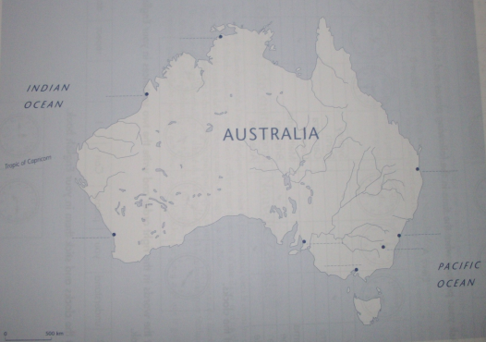

Exercise 2 : Write in the holes.

………………… is a very ……........…. country and time can be

……………………. from one place to …………………...

U5 (année 2)- What time is it ?
Savoir donner l’heure avec les minutes (past).

Lesson 2

Exercise 1 : What time is it ?

........................................................... ...........................................................

........................................................... ...........................................................

...........................................................

Color in blue the part corresponding to past.

Exercise 2 : What time is it ?

...........................................................

...........................................................

Color in blue the part corresponding to past.

Exercise 3 : Ask your partner what the time in the following places and tick the right box.

Travailler par deux : Poser la question What time is it in .....................?
Répondre It's .........................................
Si je n'ai pas compris alors je réponds I don't understand. Can you repeat, please ?
Le but étant de remplir tout son tableau. Attention écrire le dialogue.
A cause du décalage horaire, il n'est pas la même heure dans toute l'Australie, retrouve l'heure de chaque ville.

Sydney |  |  | A
Perth | A
Canberra |  |  | B
Darwin |  | B
Melbourne |  |  | B
Brisbane |  |  | A
Broome | B
Adelaïde |  | A

A : What time is it in ............................................................. ?

B : It's ......................................................................................

B : What time is it in ............................................................. ?

A : It's. ......................................................................................

A : What time is it in ............................................................. ?

B : It's ......................................................................................

B : What time is it in ............................................................. ?

A : It's ......................................................................................

A : What time is it in ............................................................. ?

B : It's ......................................................................................

B : What time is it in ............................................................. ?

A : It's......................................................................................

A : What time is it in ............................................................. ?

B : It's ......................................................................................

B : What time is it in ............................................................. ?

A : It's ......................................................................................

U5 (année 2)- What time is it ?
Connaître l’écriture des nombres de 1 à 30. Savoir donner l’heure avec les minutes (to).

Lesson 3

Exercise 1 : Write the numbers.
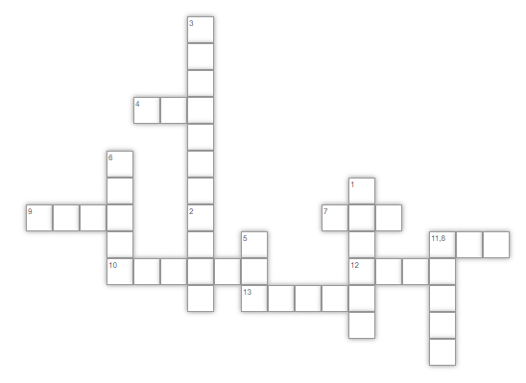
Exercise 2 : What time is it ?

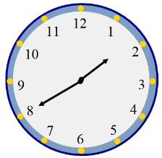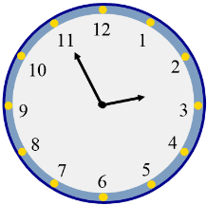

........................................................... ...........................................................

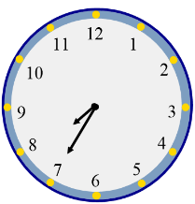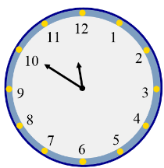
........................................................... ...........................................................

Color in green the part corresponding to to.

Exercise 3 : Write the right sentences.

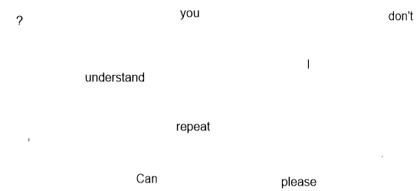

.............................................................................................................................

.............................................................................................................................

U5 (année 2)- What time is it ?
Connaître le vocabulaire autour de l’heure (a quarter).

Lesson 4

Exercise 1 : What time is it ?

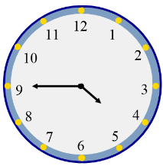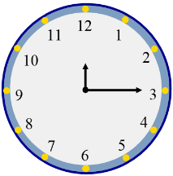

........................................................... ...........................................................

Color in green the part corresponding to to and color in blue the part corresponding to past.

Exercise 2 : Listen the song and put in order.
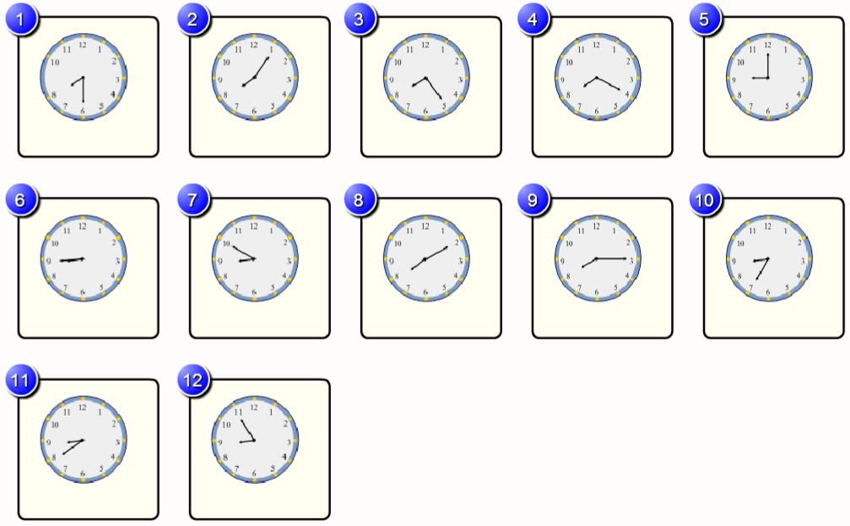

.............................................................................................................................

Exercise 3 : Write the tongue twister.

.............................................................................................................................

U5 (année 2)- What time is it ?
Connaître les réponses courtes.
Lesson 5

Exercise 1 : Write the answers.

Can you repeat please ? ...........................................................

Can you come here, please ? ...........................................................

Can you speak Italian ? ...........................................................

U6 (année 2)- May I...
Connaître les sports de la Nouvelle Zélande.
Lesson 1

Exercise 1 : Write the sports.
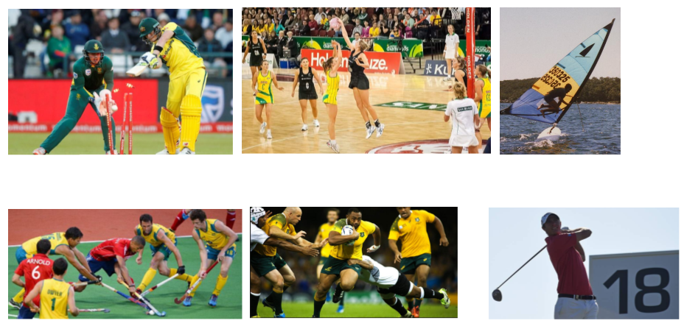

Exercise 2 : Write in the holes.

.................................., ..........................................., …......................…… and

........................... are …………………….. sports in …………………….

U6 (année 2)- May I...
Connaître les verbes d’action.

Lesson 2

Exercise 1 : What can you do ?
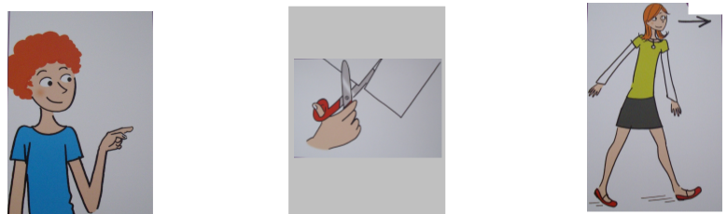

I can............................. ..................................... .....................................

I can’t........................... ..................................... .....................................

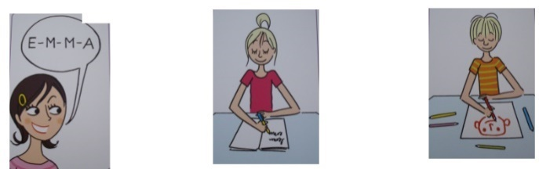

I can............................. ..................................... .....................................

I can’t........................... ..................................... .....................................

Exercise 2 : Connects the word drawing.

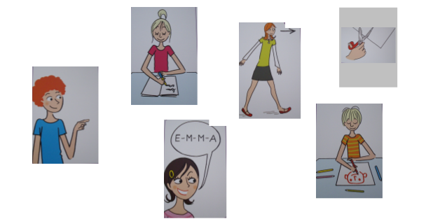
to show to write to spell
to cut to go to to draw

U6 (année 2)- May I...
Connaître les verbes d’action.

Lesson 3

Exercise 1 : Connects the word drawing.

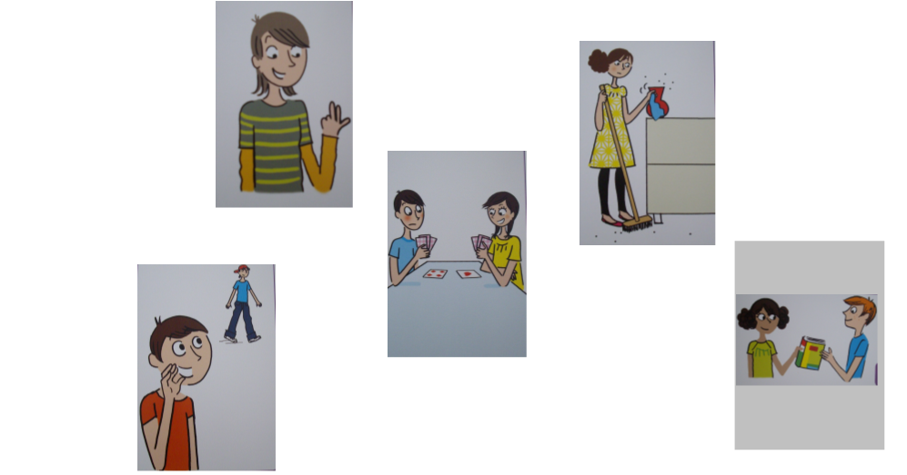
to count to clean to play
to call to give

Exercise 2 : Write the actions.

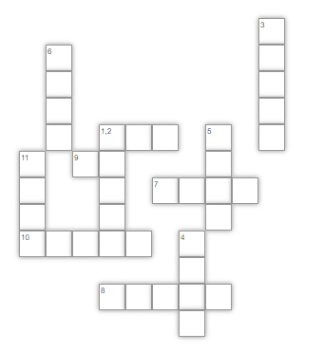

Exercise 3 : Write the tongue twister.

.............................................................................................................................

U6 (année 2)- May I...
Connaître la différence entre Can I et May I.

Lesson 4

Exercise 1 : In the song, highlights in green Can I and highlights in orange May I.
May I... ?

I am a new pupil.
May I call you "Headmaster" ?
I don't have my pencil.
Can I have a blue marker ? (x2)

Clean the board !
Write the date !
Clean the board !
Write ! (x2)

I've got the big ruler.
May I write on the blackboard ?
Are you my new teacher ?
Can I go and clean the board ? (x2)

Refrain

May I call you "Headmaster" ?
May I ? May I ?
May I write on the blackboard ?
May I ? May I ?
Can I have a blue marker ?
Can I ? Can I ?
Can I go and clean the board ?
Can I ? Can I ?

Refrain (x2)

Exercise 2 : Write the right sentences and write the answers.
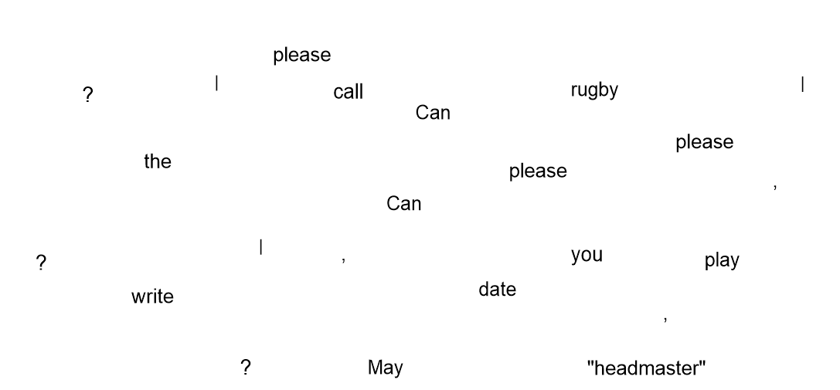

.........................................................................................................................

.............................................................

.........................................................................................................................

.............................................................

.........................................................................................................................

.............................................................

U7 (année 2)- Is it your coat ?
Connaître les symboles de l’Irlande. Connaître la carte du Royaume-Uni. Connaître quelques vêtements.

Lesson 1

Exercise 1 : Write the words.

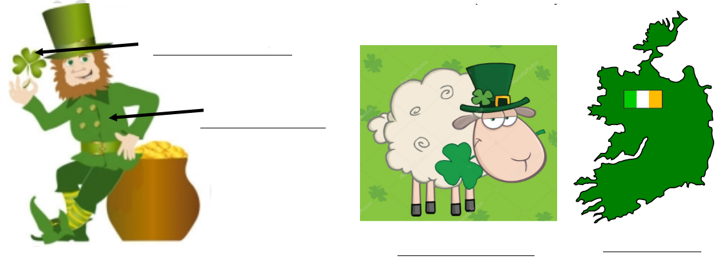

Exercise 2 : Write in the holes.

The ……………………………., the .............................. and the

............................. are the ………...........…… of ............................................

Exercise 3 : Color on the map, Ireland in green and United Kingdom in orange.
Do not forget to write Ireland of Northern and Republic of Ireland

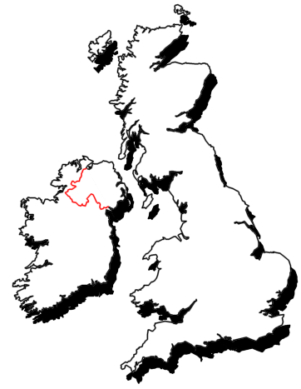
Exercise 4 : Write the clothes.
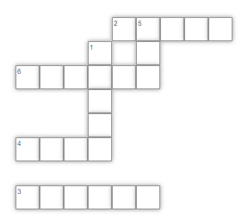

U7 (année 2)- Is it your coat ?
Connaître quelques vêtements.
Lesson 2

Exercise 1 : Write the word under the picture : a blouse, a shirt, a skirt, a jacket, a coat, a hat.

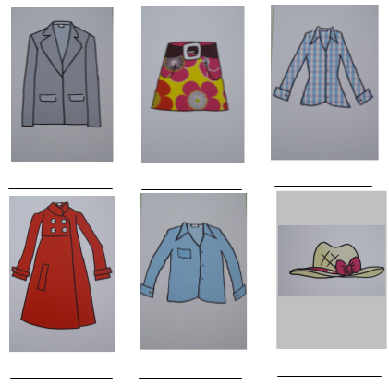

U7 (année 2)- Is it your coat ?
Connaître quelques vêtements.
Lesson 3

Exercise 1 : Connects the word drawing.

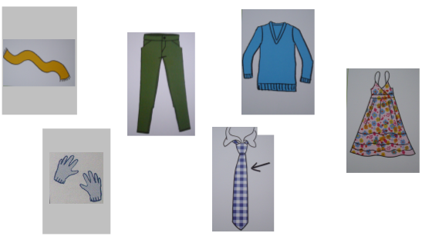
a scarf a tie a jumper
gloves a dress trousers

Exercise 3 : Listen the song and dress up the girl.
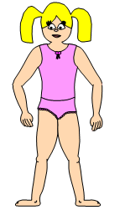
Exercise 2 : Write for each person his clothes.
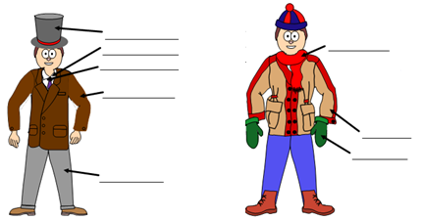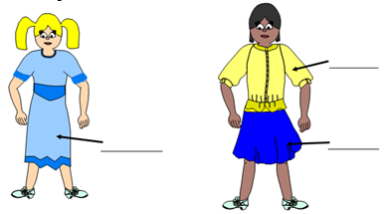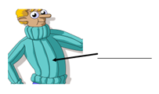

U7 (année 2)- Is it your coat ?
Connaître quelques vêtements. Connaître les réponses courtes.
Lesson 4

Exercise 1 : Write the sentences.

? | your | Is | skirt | it

...........................................................................................................................

it | . | Yes | is | ,

...........................................................................................................................

it’s | it | , | No | isn’t | but | jumper | . | his

............................................................................................................................

Exercise 2 : Listen the song and for each clothes, write question and short answer for the girl.

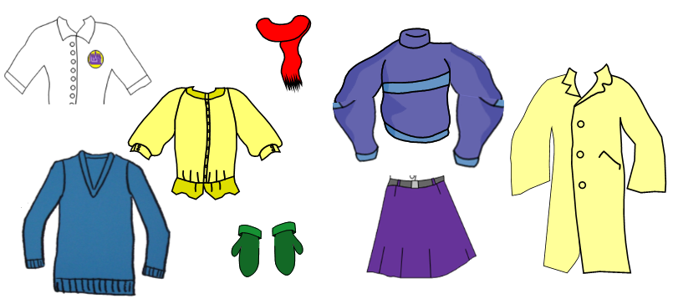
Example : Is it her shirt ?
No, it isn’t.

............................................................................................................................

....................................................................

............................................................................................................................

....................................................................

............................................................................................................................

....................................................................

............................................................................................................................

....................................................................

............................................................................................................................

....................................................................

............................................................................................................................

....................................................................

............................................................................................................................

....................................................................

Exercise 3 : Write the tongue twister.

............................................................................................................................

Exercise 4 : What does he/she wear ?

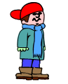
........................................................................................

........................................................................................

........................................................................................

........................................................................................

........................................................................................

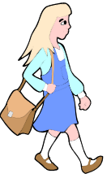
........................................................................................

........................................................................................

........................................................................................

........................................................................................

........................................................................................

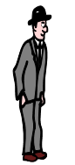
........................................................................................

........................................................................................

........................................................................................

........................................................................................

........................................................................................

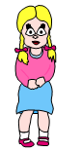
........................................................................................

........................................................................................

........................................................................................

........................................................................................

........................................................................................

U8 (année 2)- Do you know my pet ?
Connaître quelques adjectifs.

Lesson 1

Exercise 1 : Connects the sentence drawing.
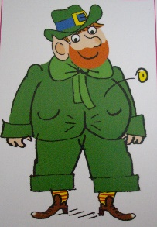
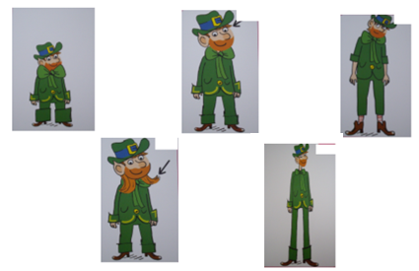

He’s got a short hair. He is thin. He’s got a long hair.
He is small. He is tall.
He is fat.

Exercise 3 : Write in the holes.

In Ireland, people celebrate …………………………… on March 17th. On

that day, everybody wears ………………………. clothes.

Exercise 2 : Write the adjectives.
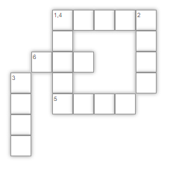

U8 (année 2)- Do you know my pet ?
Connaître quelques adjectifs.

Lesson 2

Exercise 1 : Write the sentence under the picture.

Exercise 2 : Illustrates the song.

Do you know my pet ?

Do you know my country ? (x2)

Yes I do,
No, I don't... no, I don't.

It's in Europe.
It's a green land.

My Brother lives there.
It's Ireland !

Do you know my Brother ? (x2)

Yes I do,
No, I don't... no, I don't.

He's a nice boy.
He's got a small pet.
He's a black cat,
His name is "Puppet" !

Do you know his small pet ? (x2)

Yes I do,
No, I don't... no, I don't.

Yes I know your country. (x2)
Yes I know your brother. (x2)
Yes I know your small pet. (x2)
He's Puppet... (x5)

U8 (année 2)- Do you know my pet ?
Connaître quelques adjectifs. Connaître les parties du corps.

Lesson 3

Exercise 1 : Connects the sentence drawing.
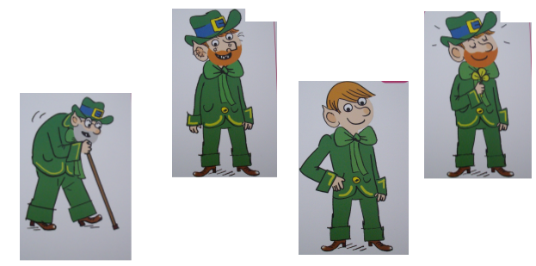

Leprechaun is old. Leprechaun is ugly.
Leprechaun is young. Leprechaun is nice.

Exercise 2 : Write the body parts : eyes, body, hair, nose, finger, mouth, shoulder, arm, head, leg, hand, neck, foot/feet, ear
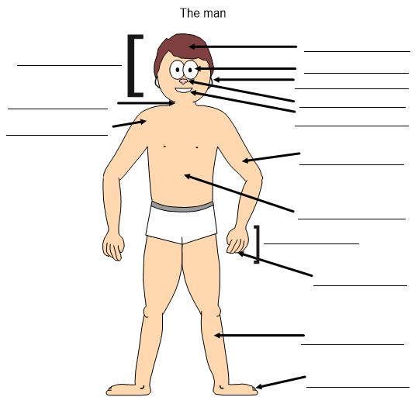

Exercise 3 : Listen and draws my monster.

U8 (année 2)- Do you know my pet ?
Savoir décrire un personnage.

Lesson 4

Exercise 1 : Write the right sentences (two sentences).

hair | Do | long | you | ? | my | ‘s | She | mother | .

got | know | eyes | green | and

.............................................................................................................................

.............................................................................................................................

Exercise 2 : Circle the pictures in the song.

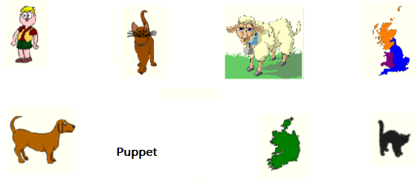

Exercise 3 : Write the tongue twister.

............................................................................................................................

Exercise 4 : Do you know my family ?

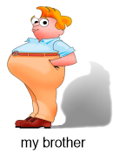
Do you know my brother ?

........................................................................................

........................................................................................

........................................................................................

........................................................................................

........................................................................................

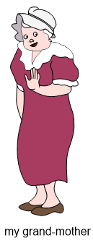
Do you know my grand-mother ?

........................................................................................

........................................................................................

........................................................................................

........................................................................................

........................................................................................

Do you know my father ?

........................................................................................

........................................................................................

........................................................................................

........................................................................................

........................................................................................

Do you know Pinocchio ?

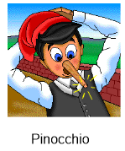
........................................................................................

........................................................................................

........................................................................................

........................................................................................

........................................................................................

U9 (année 2)- Yesterday, today and tomorrow
Connaître le temps qu’il fait.

Lesson 1

Exercise 2 : Cuts the labels and sticks them.
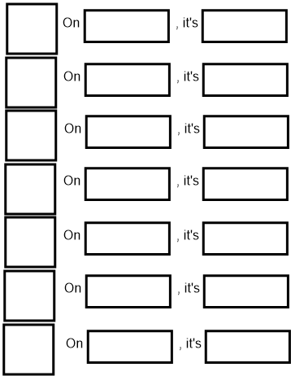
Exercise 3 : Write in the table the days and the weather : snowy, tuesday, friday, foggy, saturday, cloudy, stormy, sunday, monday, sunny, rainy, wednesday, thursday, windy

The days | The weather

Exercise 1 : Write in the holes.

…………………… is the Loch Ness Monster. He's a ……………. monster,

he's got a ......………….. neck and a very ………….. head. He lives in the

………… ………….., a lake in …………………………...

U9 (année 2)- Yesterday, today and tomorrow
Connaître le temps qu’il fait.

Lesson 2

Exercise 1 : Write in the holes.
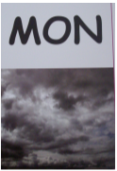

What is the weather like on ................................... ?

It's ...............................................

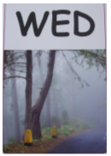

What is the weather like on ................................... ?

It's ...............................................

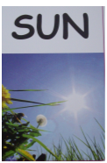

What is the weather like on ................................... ?

It's ...............................................

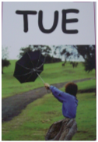

What is the weather like on ................................... ?

It's ...............................................

What is the weather like on ................................... ?

It's ...............................................

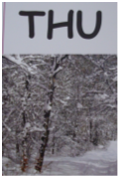
What is the weather like on ................................... ?

It's ...............................................

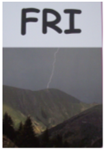
What is the weather like on ................................... ?

It's ...............................................

Exercise 2 : Ask your partner what the weather in the country and draw the weather.

Travailler par deux : Poser la question What's the weather like in ...............?
Répondre It's .........................................
Si je n'ai pas compris alors je réponds I don't understand. Can you repeat, please ?

Place | England  A | Canada  B | Australia  A | Ireland  A | Scotland  B | South Africa  B
Weather

A : What's the weather like in .............................................. ?

B : In .............................., it's .................................................

B : What's the weather like in .............................................. ?

A : In .............................., it's .................................................

A : What's the weather like in .............................................. ?

B : In .............................., it's .................................................

B : What's the weather like in .............................................. ?

A : In .............................., it's .................................................

A : What's the weather like in .............................................. ?

B : In .............................., it's .................................................

B : What's the weather like in .............................................. ?

A : In .............................., it's .................................................

U9 (année 2)- Yesterday, today and tomorrow
Connaître le passé, le présent et le futur.

Lesson 3

Exercise 2 : Write the sentence.
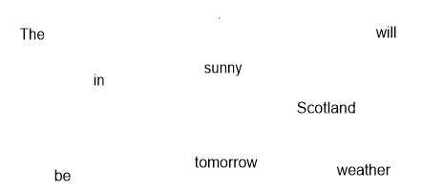
..............................................................................................................................

Exercise 3 : Write the sentence.

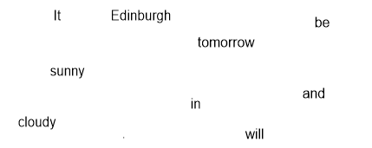
..............................................................................................................................

Exercise 4 : Match.

It was windy in England. • • tomorow

It will be foggy in Scotland . • • today

It is sunny in Ireland • • yesterday

Exercise 1 : What is the weather like ........... ?

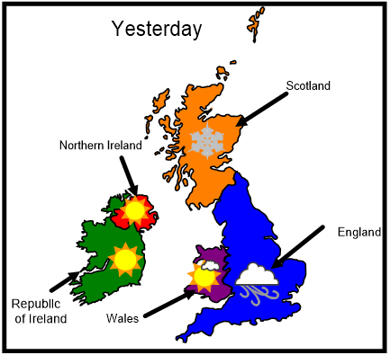

Example : Yesterday was Sunday. In Wales, it was cloudy and sunny.

.............................................................................................................................

.............................................................................................................................

.............................................................................................................................

.............................................................................................................................
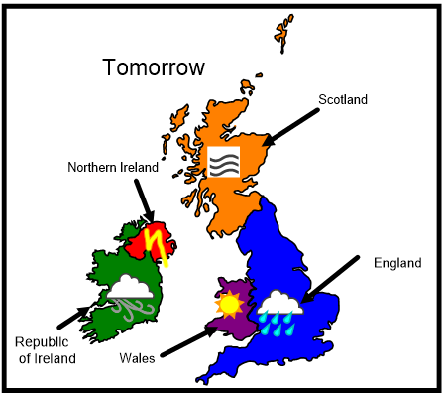
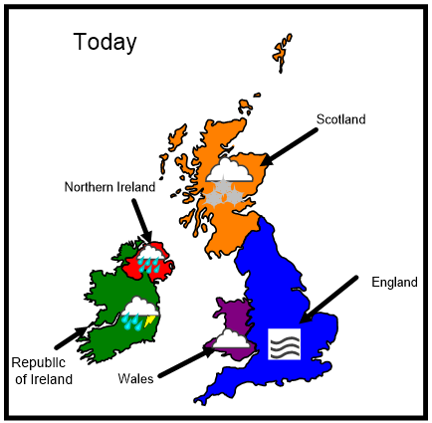

Example : Today is Monday. In Scotland, it is cloudy and snowy.

.............................................................................................................................

.............................................................................................................................

.............................................................................................................................

.............................................................................................................................

Example : Tomorrow will be Tuesday. In Republic of Ireland, it will be cloudy and windy.
.............................................................................................................................

.............................................................................................................................

.............................................................................................................................

.............................................................................................................................

Exercise 5 : Listen the song and illustrate it.

First part : Draw the weather.

 | Australia | My country | South Africa
Yesterday
Today
Tomorrow

Second part : Draw the weather.

 | Ireland | My country | England
Tomorrow
Yesterday
Today

Third part : Draw the trip from Monday to Sunday.
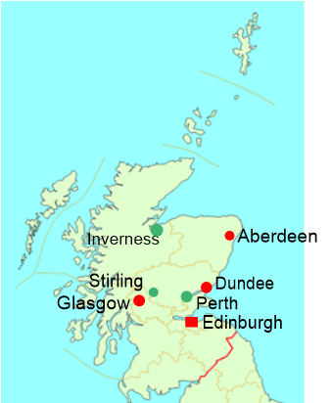
U9 (année 2)- Yesterday, today and tomorrow
Connaître les connecteurs.

Lesson 4

Exercise 1 : Play in the oral.

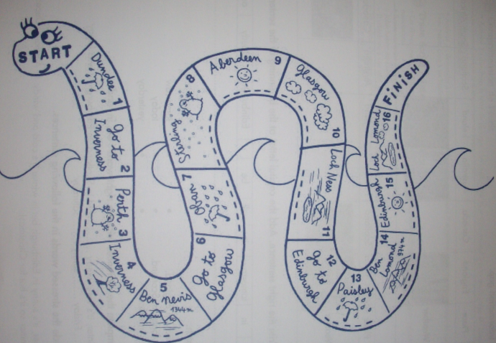
Si le dé indique 1 ou 2, le joueur utilise une phrase au passé pour indiquer le temps de la veille.
Si le dé indique 3 ou 4, le joueur utilise une phrase au présent pour indiquer le temps de la journée.
Si le dé indique 5 ou 6, le joueur utilise une phrase au futur pour indiquer le temps du lendemain.

Exercise 2 : Write the tongue twister.

.............................................................................................................................

Exercise 3 : Complete the sentences with the right word : on, in, and.

................... winter, it's very windy ..................... cold in Scotland.

In Edinburgh, it was foggy .............. cloudy ....................... Friday

......................sunny ............... Saturday.

U10 (année 2)- How many...
Connaître quelques aliments. Savoir dénombrer.

Lesson 1

Exercise 1 : Write in the holes.

………………………… eat sweet ……………………, seafood, fish,

……………………., bredies, mealie soupe and melktart.

Exercise 2 : Write the word under the picture : an egg, an apple, a banana, a cherry, a cake, a biscuit

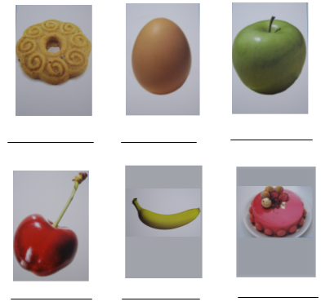

Exercise 3 : Count the objets.

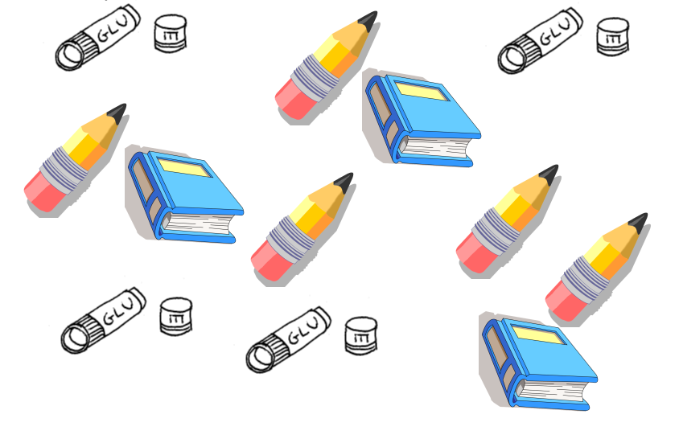
.............................................................................................................................

.............................................................................................................................

.............................................................................................................................

.............................................................................................................................

U10 (année 2)- How many...
Connaître quelques aliments. Savoir dénombrer.

Lesson 2

Exercise 1 : Count the objets.

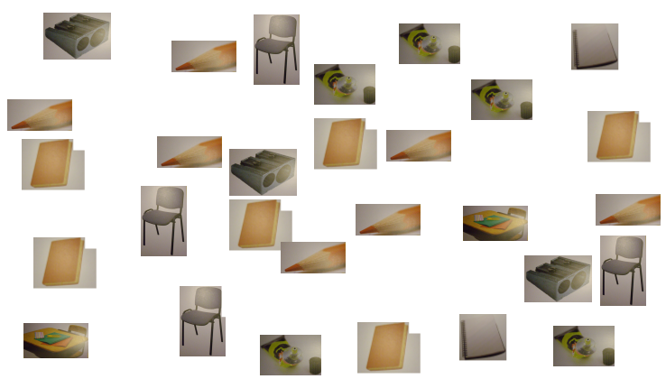
.............................................................................................................................

.............................................................................................................................

.............................................................................................................................

.............................................................................................................................

.............................................................................................................................

.............................................................................................................................

.............................................................................................................................

Exercise 2 : Write the questions and the answers.
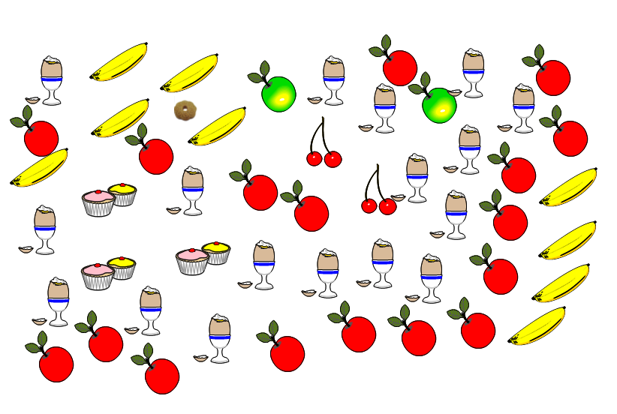
Example : How many green apples are there ?
There are two green apples.

.............................................................................................................................

......................................................................................................

.............................................................................................................................

......................................................................................................

.............................................................................................................................

......................................................................................................

.............................................................................................................................

......................................................................................................

.............................................................................................................................

......................................................................................................

.............................................................................................................................

......................................................................................................

Exercise 3 : Anagram

gges : ...................................

palpse : .................................

nsbnaaa : ..............................

recreish : ..............................

escak : ...................................

U10 (année 2)- How many...
Connaître quelques aliments. Différencier How much et How many.

Lesson 3

Exercise 1 : Connects the word drawing.
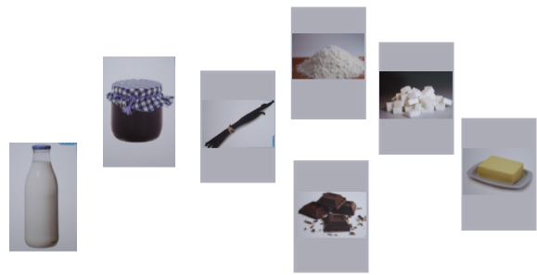

butter vanilla
flour chocolate jam
sugar milk

Exercise 2 : Listen the song and put in order.

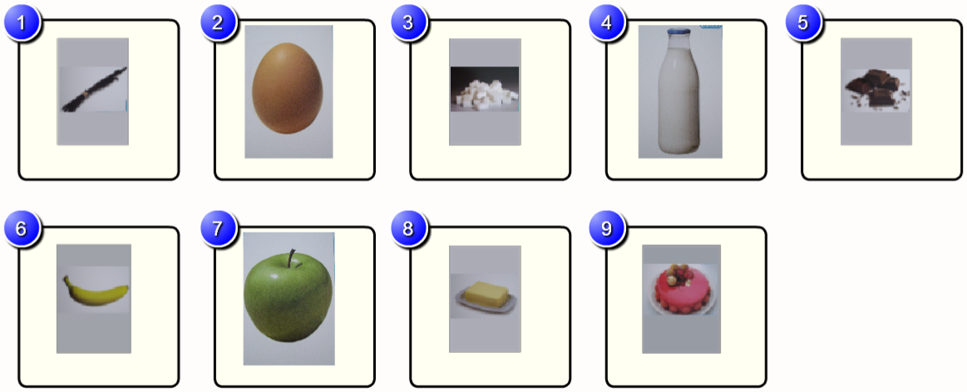
............................................................................................................................

Exercise 3 : Write the sentences.

? | How | is | much | there | sugar

............................................................................................................................

How | apples | many | there | are | ?

............................................................................................................................

There | five | are | . | eggs

............................................................................................................................

U10 (année 2)- How many...
Connaître quelques parties de la maison.
Différencier How much et How many.

Lesson 4

Exercise 1 : In the oral : What’s in the cake ? How much .... or How many.....

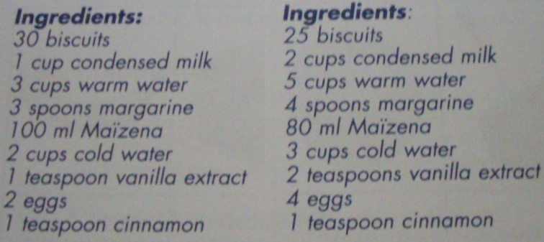

Exercise 2 : Write the tongue twister.

.............................................................................................................................

U11 (année 2)- My house
Lesson 1

Exercise 1 : Write in the holes.

In ………………, people live in a .............................., or a building.

In Great Britain, people live in a ................................, a terraced house, a

detached house or a ……………………….

Exercise 2 : Write the parts of house.

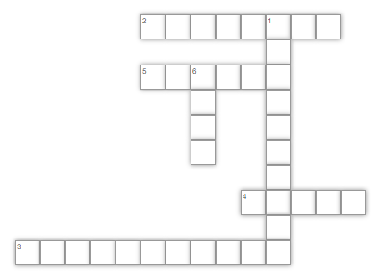

U11 (année 2)- My house
Connaître quelques parties de la maison.
Lesson 2

Exercise 1 : Write the word under the picture : the house, the garden, the corridor, the roof, the nursery room, the dining room.

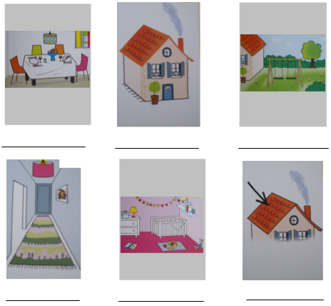

Exercise 2 : Listen the song and answer the questions.

Where does she come from ?

......................................................................................................................

Where does she live ?

......................................................................................................................

Where does he come from ?

......................................................................................................................

Where does he live ?

......................................................................................................................

Where do you live ?

......................................................................................................................

U11 (année 2)- My house
Connaître quelques parties de la maison.
Lesson 3

Exercise 1 : Connects the word drawing.
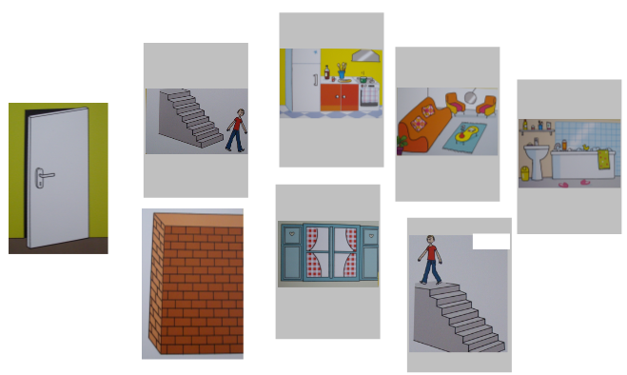
the kitchen the window downstairs
the living room the door the wall
the bathroom upstairs

Exercise 2 : Tick the boxes and write the sentences. What’s in my house ? In my house, there is .............. and ..............

1/..........................................................................................................................

.............................................................................................................................

2/..........................................................................................................................

.............................................................................................................................

Exercise 3 : Listen the song and put in order.

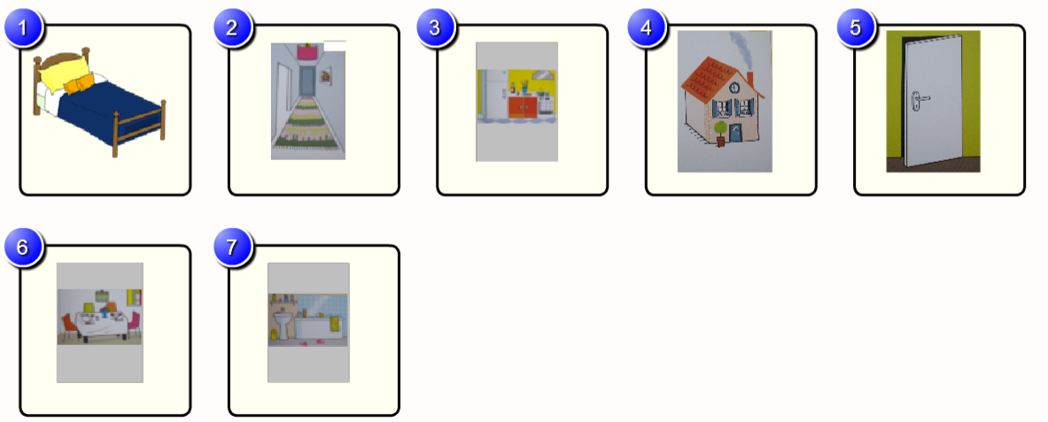

.............................................................................................................................

U11 (année 2)- My house
Savoir demander où on habite.
Lesson 4

Exercise 1 : Write the sentences.

? | Where | Live | do | you

.............................................................................................................................

does | live | Where | ? | He

.............................................................................................................................

in | house | a | She | . | Lives

.............................................................................................................................

Exercise 2 : Write the tongue twister.

.............................................................................................................................

Révision 1 (année 2) – Draw a….MONSTER !!!
Connaître les parties du corps, les couleurs, les formes, etc…

Exercise 1 : Draw a face !

My monster has an orange head. My monster has blue hair. My monster has yellow eyes. My monster has a red nose. My monster has purple ears. My monster has a pink mouth.

Exercise 2 : Draw a face !

My monster has three heads. My monster has six eyes. My monster has three noses. My monster has no hair. My monster has one mouth. My monster has four ears.

Exercise 3 : Draw a monster !

My monster has a blue head. My monster has red hair. My monster has purple eyes. My monster has a brown nose. My monster has yellow ears. My monster has a black mouth. My monster has a pink neck. My monster has an orange body. My monster has rainbow arms. My monster has grey legs. My monster has black feet.

Exercise 4 : Draw a monster !

My monster has two heads. My monster has one eye. My monster has three noses. My monster has four mouths. My monster has two ears. My monster has one body. My monster has five arms, two on the right and three on the left, and five hands, each with three fingers. My monster has six legs and six feet.

Révision 2 (année 2) – Draw a….MONSTER !!!
Connaître les parties du corps, les couleurs, les formes, etc…

Exercise 1 : Draw a face !

My monster’s head is a circle. His eyes are squares. His ears are triangles. His nose is a rectangle and his mouth looks like the mouth of a Halloween pumpkin.

Exercise 2 : Draw a face !

My monster’s head is a blue rectangle. His eyes are green circles. His ears are two purple squares. His nose is a pink triangle and his mouth looks like the mouth of a vampire.

Exercise 3 : Draw a monster !

My monster’s head is a blue heart. His eyes are green squares. His ears are yellow ovals. His mouth is a red triangle. His nose is a black rectangle. His body is a big green diamond. His arms are long blue rectangles and his hands two red triangles. His legs are two series of orange circles and his feet two pink rectangles.

Exercise 4 : Draw a monster !

My monster’s head is a red star. His eyes are four blue circles. His ears are four yellow diamonds. His mouth is a pink heart. His nose is a grey pentagon. His body is a big green rectangle. His arms are long brown rectangles and his hands two black triangles. His legs are two series of purple ovals and his feet two red hexagons.

Révision 1 (année 2) – Vocabulary : The beach 1
Connaître le vocabulaire de la plage.

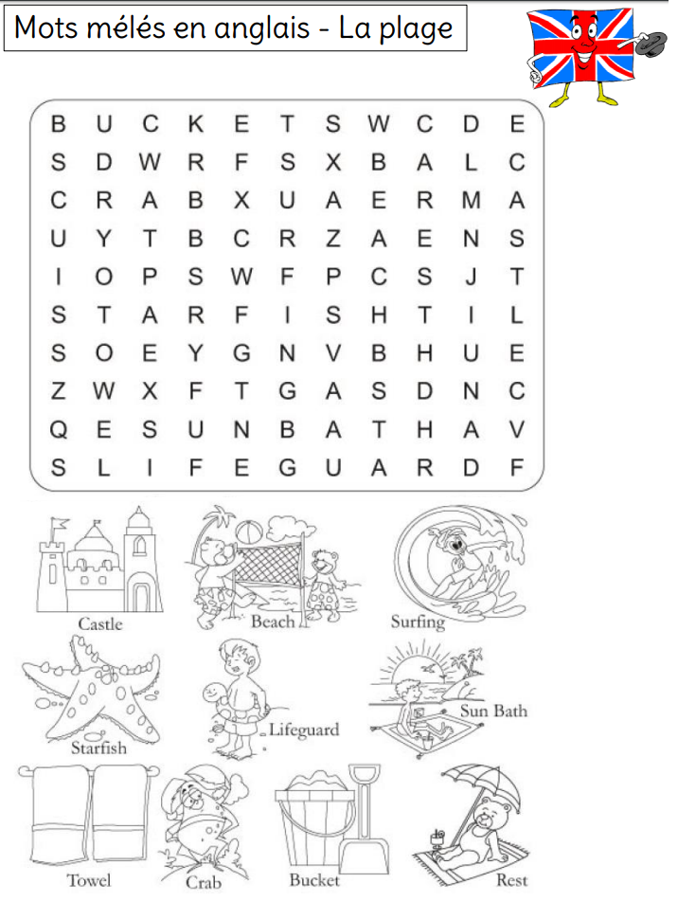
Révision 2 (année 2) – Vocabulary : The beach 2
Connaître le vocabulaire de la plage.

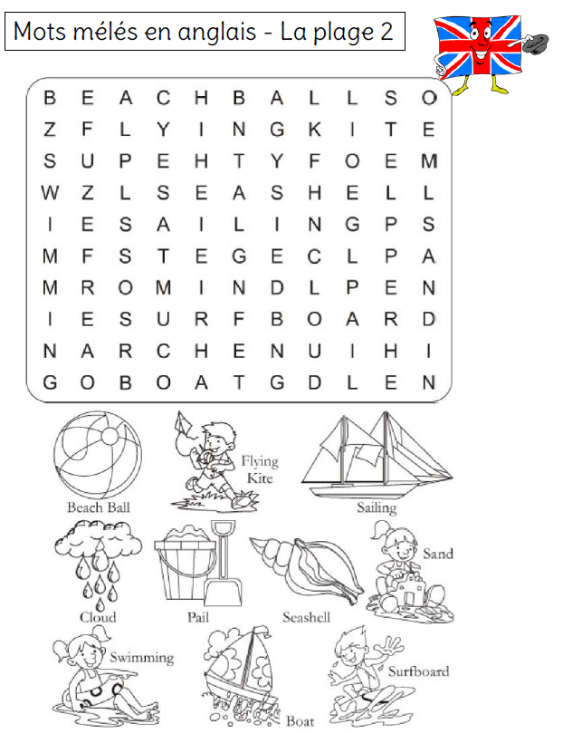

Révision 3 (année 2) – Draw a….MONSTER !!!
Connaître les parties du corps, les couleurs, les formes, etc…

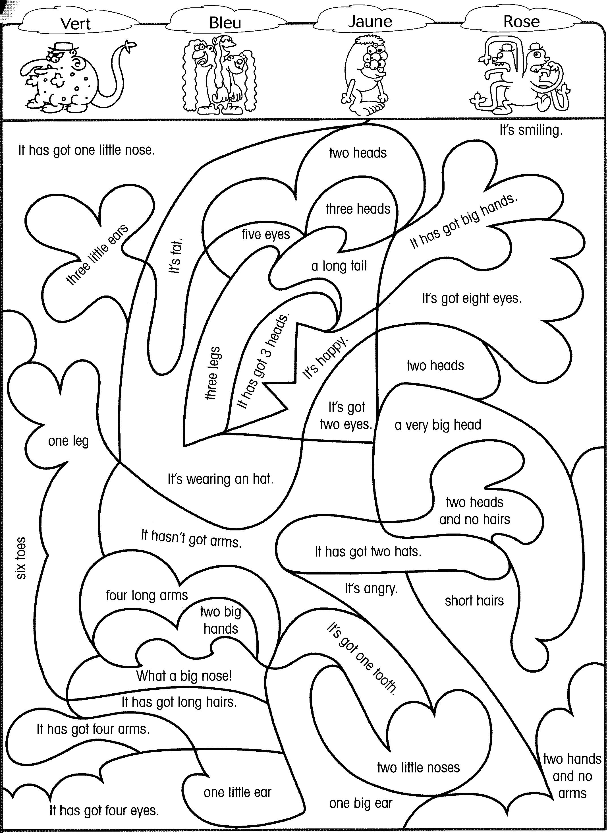
Green Blue Yellow Pink

Révision 3 (année 2) – Vocabulary : The animals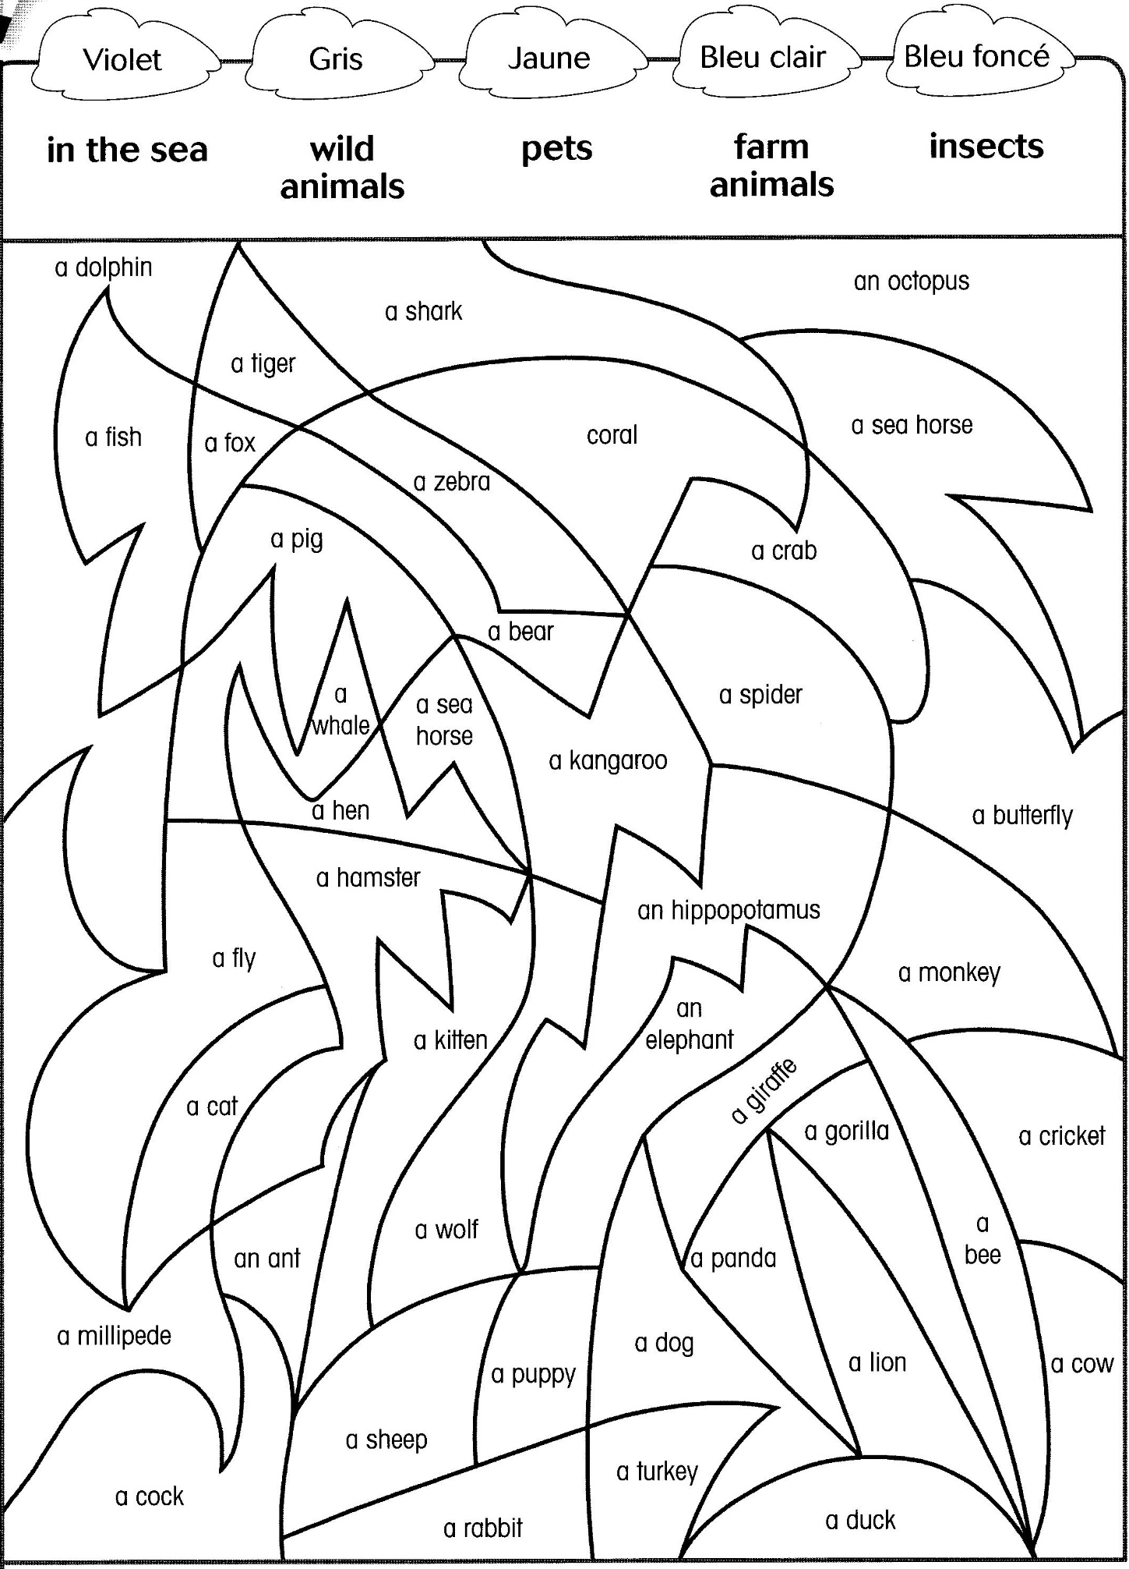
purple grey yellow light blue dark blue
Connaître le vocabulaire des animaux.

Révision 4 (année 2) – Vocabulary : The park
Connaître le vocabulaire du park.

