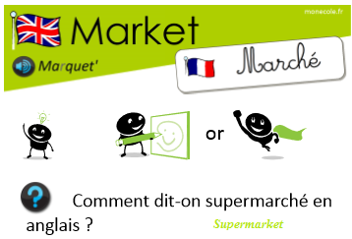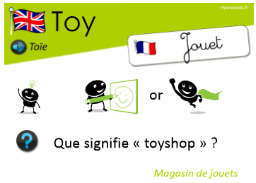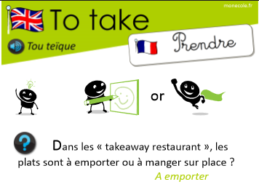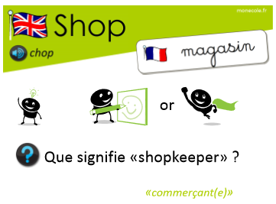
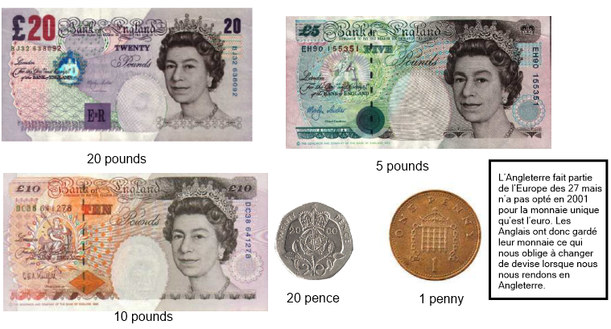
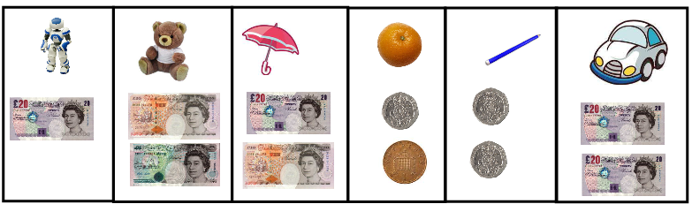

How much is the pencil ? It's forty pence

How much is the car ? It's forty pounds

How much is the orange? It's twenty-one pence

How much is the robot? It's twenty pounds

How much is the teddy bear? It's fifteen pounds

How much is the umbrella ? It's thirty pounds

