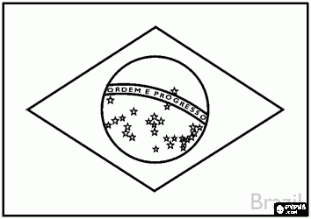
Le Brésil

Nous allons écouter la musique « Samba break ». Celle-ci évoque la musique du carnaval de Rio qui est célèbre dans le monde entier. Musiciens et danseurs font la fête dans la rue pendant quatre jours et quatre nuits consécutifs. Le carnaval est la fête la plus populaire au Brésil, à Rio de Janeiro en particulier. La samba est le rythme endiablé de cette musique. Lors de la fête, les différentes écoles de samba défilent. Certains groupes comptent jusqu’à 3 000 personnes costumées.

Ecoute Samba de "Break" Brunno Damasceno :
http://www.youtube.com/watch?feature=player_detailpage&v=bQeBckmv5C4

